Norfolk County Council proposes to make a Temporary Traffic Regulation Order (the “Order”) (NTRO9652) affecting the C643 Sea Palling Road from its junction with C643 Water Lane to its junction with U19279 Horsey Gap (“Road A”) and C643 Palling Road from its junction with U19279 Horsey Gap to its junction with C643 Bulmer Lane (“Road B”) and; C643 Bulmer Lane from its junction with C643/120 Somerton Road to its junction with C643 Yarmouth Road roundabout (“Road C”) in the Parishes of Ingham, Horsey, Winterton-On-Sea, Somerton, Hemsby, Sea Palling and Ormesby St Margaret to facilitate stud removal, main dressing and stud replacement with lining works, the Roads A-C will be temporarily closed/restricted (except for pedestrian access) for the duration of the works/period the closures is necessary which is anticipated in the following phases: Road A (Phase 1) anticipated between 19:00 and 05:00 from 6th to 9th June 2025. Road B (Phase 2) anticipated between 06:00 and 16:00 from 9th to 14th June 2025 and Road C (Phase 3) anticipated between 19:00 and 05:00 from 23rd to 28th June 2025 only whilst signs indicating closures are in place; but may continue to be closed/restricted until the 28th December 2025 where the closures/restrictions are still required beyond the anticipated dates. NB: Please note that only one phased closure will be in place at any one time.

Alternative route is via:
Road A: C641 Sea Palling Road/ Town Road/ Ingham Road, C412 Brumstead Road, B1159 Stepping Stone Lane, A149 Wayford Road/ Yarmouth Road/ Bypass/ Yarmouth Road/ High Road, C640 Repps Road/ White Street/ Somerton Road/ Martham Road/ Horsey Road/ Somerton Road/ Palling Road.
Road B: C643 Coast Road/ Waxham Road/ Stalham Road, C641 Sea Palling Road/ Town Road/ Ingham Road, C412 Brumstead Road, B1159 Stepping Stone Lane, A149 Wayford Road/ Yarmouth Road/ Bypass/ Yarmouth Road/ High Road/ Main Road, C591 Cromer Road/ Yarmouth Road, C643 Scratby Road/ Yarmouth Road/ Hemsby Road.
Road C: C643 Winterton Road, C640 Martham Road/ Somerton Road/ White Street/ Repps Road, A149 Main Road, C591 Cromer Road/ Yarmouth Road.

(Stalham, Ingham, Hickling, Repps with Bastwick, Rollesby, Potter Heigham, Catfield, Ormesby St. Michael, Ormesby St. Margaret with Scratby, Sutton, Martham, Somerton).

The works promoter for this restriction/closure is: Norfolk County Council.

Vehicular access will be permitted to a final destination in the Roads A-C where signs indicating such access is possible and permitted are in place.

The Order shall automatically revoke on the completion of the works/when the closure is no longer necessary or otherwise on the 28th December 2025 without further notice.

If necessary, the restriction could run for a maximum period of 18 months from the date the Order is effective.

A person who contravenes, or who uses or permits the use of a vehicle in contravention of the restriction/closure imposed by the Order shall be guilty of an offence.

Penalty: £1000 maximum fine on conviction and/or endorsement for contravention.

In the event of the start date being delayed the new start date will be displayed on site in advance.

Full details on the closures are available at https://one.network. Any enquiries that cannot be answered on the one.network website should be directed to the North Area Streetworks (Community and Environmental Services Department) contactable by telephone at 0344 800 8020 or email at streetworks@norfolk.gov.uk

Dated this 23rd day of May 2025.

Katrina Hulatt
Director of Legal Services (nplaw)
County Hall
Martineau Lane
Norwich
NR1 2DH

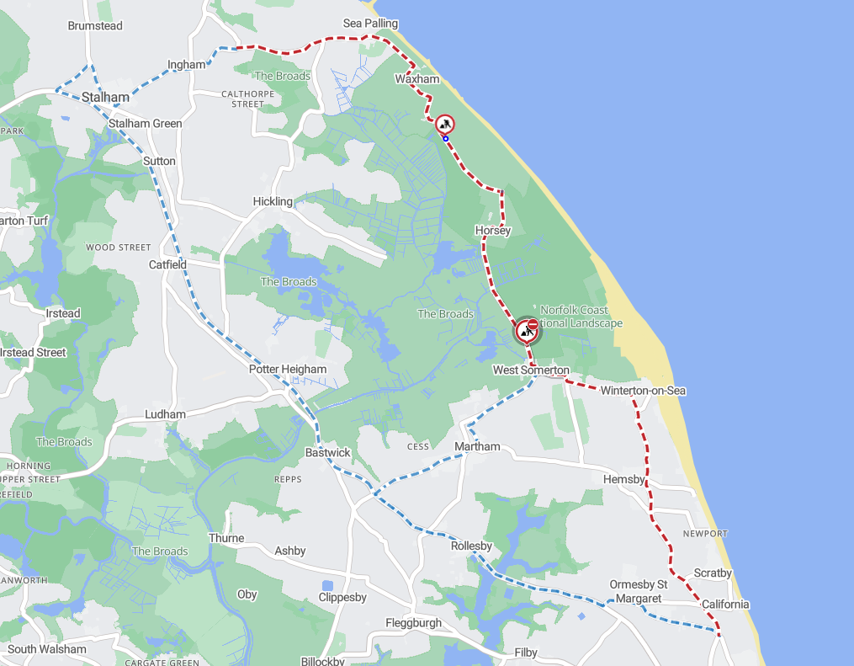
Imagery © 2025 maptiler | imagery © 2025 hexagon | © maptiler © openstreetmap contributors

