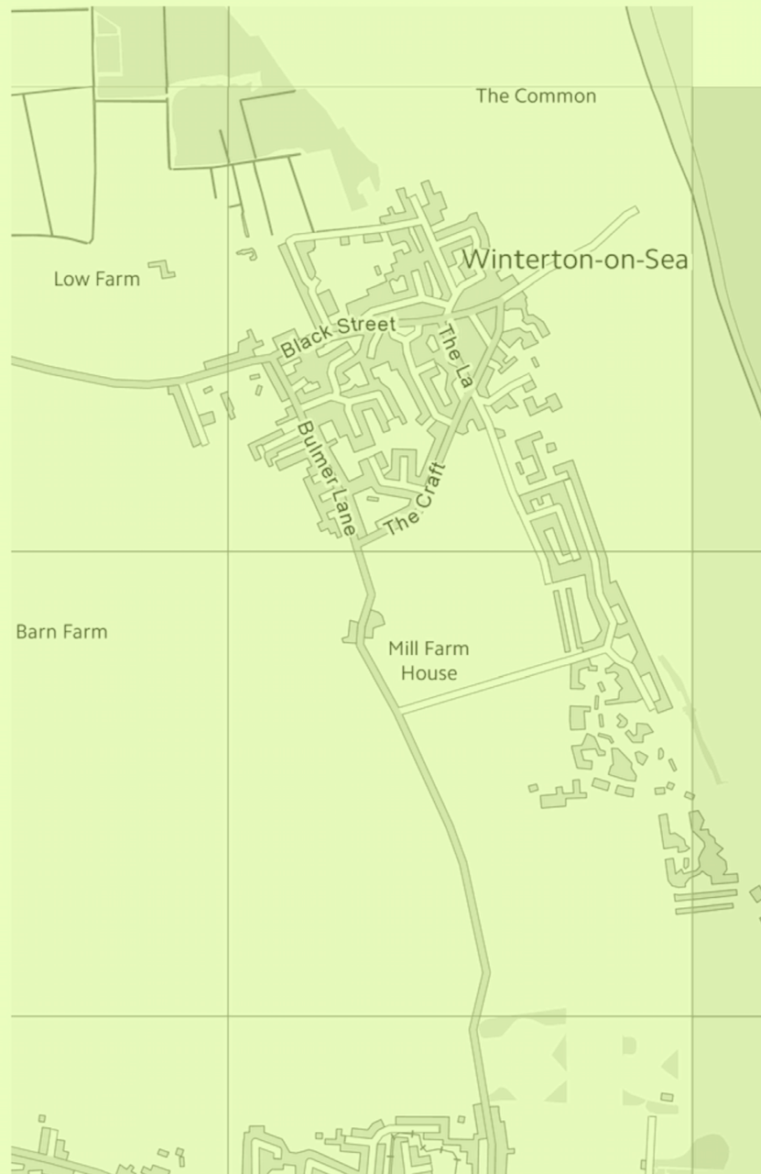
Winterton-on-Sea Neighbourhood Plan

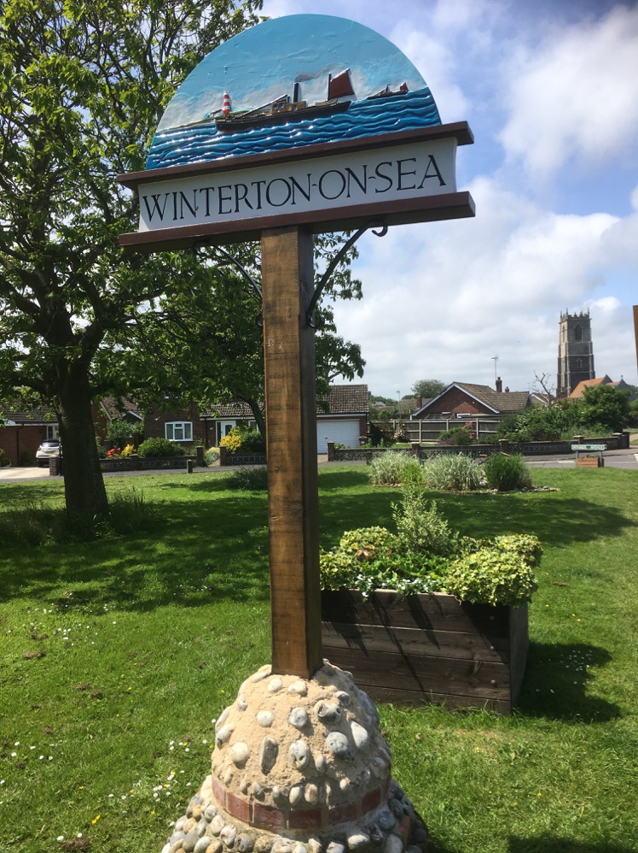
Regulation 14:
Consultation Questionnaire

INTRODUCTION

We now have a draft version of the Winterton-on-Sea Neighbourhood Plan 2020-30 and would like your views on its content and policies as part of the pre-submission (Regulation 14) consultation. The consultation will run for 6 weeks from Thursday 19 March to Saturday 16 May 2020.
Copies of the draft plan are available to view online on the Winterton-on-Sea Parish Council website or in hard copy from the Clerk: clerkwinterton@gmail.com or telephone 07918 978921.

Please review the draft plan, indicate your level of support for the policies it contains and provide comments using this questionnaire.
Information given on this survey will be used to help prepare the final Winterton-on-Sea Neighbourhood Plan for examination.

Please return completed questionnaire responses to Winterton Village Hall, Kings Street, NR29 4AT or submit your response online https://www.smartsurvey.co.uk/s/Winterton-on-Sea/

SECTION 1: OVERALL VIEWS ON THE DRAFT NEIGHBOURHOOD PLAN

Q.1
I am generally in support of the plan

- Yes
- No

Q.2
I would like to see changes to the plan

- Yes
- No

Q.3
Your comments on the plan overall

SECTION 2: HOUSING POLICIES

Q.4 Policy HO1: Settlement Boundary and Residential Development

Policy HO1: Settlement boundary and residential development

Where there are no directly relevant policies to the application or the most important policies for determining the application are out of date, the Neighbourhood Plan will support proposals unless:

- The application of policies in the National Planning Policy Framework that protect areas or assets of particular importance provides a clear reason for refusing the development proposed; or

- The adverse impacts of granting permission would significantly and demonstrably outweigh the benefits when assessed against:

- The policies in the National Planning Policy Framework taken as a whole;
- Other national planning policy guidance;
- The policies in the development plan, with due weight being given according to the extent they are not considered out of date;
- The Neighbourhood Plan’s overall Vision and Objectives; and
- The following criteria:
- Proposals are not significantly detached from the village, significant being defined as further than 50m from the settlement boundary;
- Proposals do not represent a significant encroachment into the open countryside; and
- Proposals are not more than 1 hectare in size and will not result in a significant increase in the number of dwellings, with significant being more than 5% of those already within the settlement boundary.

To what extent do you agree with this policy?

- Strongly Agree
- Agree
- Not Sure
- Disagree
- Strongly Disagree

Q.5 Policy HO2: Housing Mix

Policy HO2: Housing mix

Proposals should provide a mix of housing types, especially smaller unit homes and homes suitable for younger and older residents.

New housing developments must provide a mix of housing to meet the needs of the community. Housing developments, including the conversion of existing buildings to dwellings, should provide evidence of the community need in terms of likely housing mix and as a minimum must, unless clear evidence for an alternative mix is provided, meet the following criteria:
- On schemes of more than five dwellings at least 25% of dwellings should be suitable for occupation by people who are elderly, infirm or disabled; and
- On schemes of more than five dwellings, at least 33% of those dwellings should have two bedrooms or fewer, with no other rooms that can easily be put to use as a bedroom once the dwelling has been completed.

These standards might be relaxed if a scheme can be shown to be unviable otherwise.

Separate proposals on contiguous sites that are in the same ownership and/or control, or have a planning history indicating that they have been considered together, will be considered as single proposal.

To what extent do you agree with this policy?

- Strongly Agree
- Agree
- Not Sure
- Disagree
- Strongly Disagree

Q.6 Policy HO3: Affordable Housing

Policy HO3: Affordable housing

The inclusion of affordable housing or contributions as part of proposals that would not normally be required to make such provision will be seen as delivering a significant community benefit.

Small-scale rural or entry-level exception site proposals for affordable housing that are outside of the settlement boundary as shown in the adopted local plan will be supported where:
- The proposal would help to meet a proven local housing need, as defined by the borough council;
- The site is situated within 50m of the settlement boundary;
- The proposal will enable future occupants to have reasonable and safe access to local services and facilities using sustainable means of transport; and
- The affordable/entry-level housing provided is made available to people in local housing need at an affordable cost for the life of the property (in perpetuity), in accordance with the prevailing sequential approach used by the borough council for allocating affordable housing.

To what extent do you agree with this policy?

- Strongly Agree
- Agree
- Not Sure
- Disagree
- Strongly Disagree

Q.7 Policy HO4: Design

Policy HO4: Design

Design which fails to have regard to local context and does not preserve, complement or preferably enhance the character and quality of its immediate area and the wider parish will not be acceptable. Proposals should therefore be of an appropriate density, appearance, height, variety, scale and layout, and be of a high quality design. Proposals should be well integrated, both visually and functionally, with the immediate surroundings. It is expected that affordable homes will be included in the unifying theme for all new developments, and must not be of a noticeably lower quality.

Proposals in the village centre will be supported if it contributes to the variety of design whilst reflecting and contributing towards the historic and eclectic architectural character of the village centre, building on its local distinctiveness.

Proposals outside of the village centre, see Figure 6, that are of an innovative design with high environmental standards will be supported. Proposals on the edge of or adjacent to the village will be expected to be of a density, height and layout that reflects a transition into the open countryside, with views into the countryside retained.

Proposals for new residential development comprising mainly terraced or semi-detached dwellings will be considered favourably, depending on the immediate context and the need to visually integrate.

Alterations or extensions to buildings of heritage value, whether in the village centre or not, should use traditional materials and designs for roofs, chimneys, porches, elevations, windows and doors etc.

In all cases, an exceptional standard of design will weigh significantly in favour of proposals.

Figure 6: Historic Village Centre
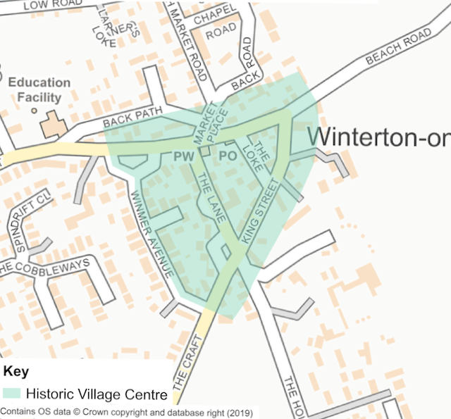

To what extent do you agree with this policy?

- Strongly Agree
- Agree
- Not Sure
- Disagree
- Strongly Disagree

Q.8 Policy HO5: Principal Residence House

Policy HO5: Principal Residence Housing

Proposals for all new housing, including new single dwellings, conversions and replacement dwellings, will only be supported where first and future occupation is restricted in perpetuity to ensure that each new dwelling is occupied only as a Principal Residence. Sufficient guarantee must be provided of such occupancy restriction through the imposition of a planning condition or legal agreement and on-going evidence. New unrestricted second homes will not be supported at any time.

To what extent do you agree with this policy?

- Strongly Agree
- Agree
- Not Sure
- Disagree
- Strongly Disagree

Q.9 Policy HO6: Tourist Accommodation

Policy HO6: Tourist accommodation

Proposals for new tourist accommodation that supports the local economy will generally be permitted in accordance with the following criteria:

- Proposals for new built permanent or semi-permanent tourist and holiday accommodation will be required, unless specific justification is provided, to locate within the settlement boundary or on sites that are well related to the village, and at a scale appropriate to the village;

- Outside of the settlement boundary, proposals for the conversion of existing buildings, including farm buildings, for tourist accommodation will be supported provided they demonstrate a creative use of the existing structures.

Any tourist accommodation must be of similar quality to residential dwellings and adhere to Policy HO4.

To what extent do you agree with this policy?

- Strongly Agree
- Agree
- Not Sure
- Disagree
- Strongly Disagree
Q.10 Do you have any comments on the housing section overall?

SECTION 3: ENVIRONMENT POLICIES

Q.11 Policy E1: Protecting and Enhancing the Environment

Policy E1: Protecting and Enhancing the Environment

Any development coming forward within the Neighbourhood Plan area is expected to result in a demonstrable net ecological gain of at least 10% with natural features incorporated in site proposals.

Proposals which specifically promote the preservation and restoration of the dunes and beach at Winterton-on-Sea will be supported.

Development proposals which incorporate significant and demonstrable conservation and/or habitat enhancement to improve biodiversity within the following areas may be supported:
- Decoy Wood and South Wood County Wildlife Site
- North Wood County Wildlife Site
- Winterton PCC Land County Wildlife Site
- Winterton-Horsey Dunes

Proposals likely to have a negative effect on notified interests of the Special Area of Conservation or Site of Special Scientific Interest will not be permitted. Allowance for development should only be permitted where a proposal will specifically aid the conservation of the site.

Development will not be permitted where it results in harm to views of the dunes or beach from public viewpoints.

To what extent do you agree with this policy?

- Strongly Agree
- Agree
- Not Sure
- Disagree
- Strongly Disagree

Q.12 Policy E2: High Grade Agricultural Land

Policy E2: High Grade Agricultural Land

Major development will only be supported on Grade 1 or 2 agricultural land that is viable arable land where special circumstances can be demonstrated, namely;
- There is a demonstrable need for the development in the proposed location and alternative sites on poorer quality land are not available; or
- Development on the site is demonstrated as the most sustainable option; or
- There is overriding community benefit.

To what extent do you agree with this policy?

- Strongly Agree
- Agree
- Not Sure
- Disagree
- Strongly Disagree

Q.13 Policy E3: Promoting Winterton-on-Sea’s Heritage

Policy E3: Promoting Winterton-on-Sea’s Heritage

New development proposed within Winterton-on-Sea must take full account of the historic character of the village, which is defined particularly by the designated Conservation Areas and Historic Village Centre.

Any landscape setting, open spaces, heritage assets, key views and vistas identified as contributing to the significance of these areas should as a minimum be maintained. Overall, development should aim to preserve and enhance the character of these important areas.

To what extent do you agree with this policy?

- Strongly Agree
- Agree
- Not Sure
- Disagree
- Strongly Disagree

Q.14 Policy E4: Flooding and Drainage

Policy E4: Flooding and Drainage

All development proposals coming forward within the areas of high, medium and low risk from surface water flooding, as identified by the Environment Agency or Strategic Flood Risk Assessment, and all developments of 5 or more properties, will need to be accompanied by a Surface Water Drainage Strategy that is proportionate to the risk and size of the development.
- This must demonstrate that the proposal will not result in any increase in the risk of surface water or groundwater flooding on site or elsewhere off-site;
- The Surface Water Drainage Strategy, including any necessary flood risk mitigation measures, should be agreed as a condition of the development before any work commences on site;
- Planning applications that improve surface water drainage in the Neighbourhood Plan area will be supported;
- Sustainable Drainage Systems must be incorporated first and foremost for all planning applications and designed in from the start; and
- Appropriate on-site water storage shall be incorporated into drainage schemes to intercept, attenuate or store long term surface water run-off.

All new development will be expected to connect to the public foul sewerage network in accordance with the requirements of Anglian Water unless evidence is produced that it is not feasible to do so. Evidence shall be provided by applicants to demonstrate that capacity is available within the foul sewerage network or can be made available in time to serve the development. If mains sewerage is not feasible then an effective and sustainable private sewerage system plan shall be agreed with the Local Planning Authority in advance of development commencing. Such a plan must be implemented prior to the occupation of the first dwelling.

To what extent do you agree with this policy?

- Strongly Agree
- Agree
- Not Sure
- Disagree
- Strongly Disagree

Q.15 Do you have any comments on the environment section overall?

SECTION 4: COMMUNITY ASSETS POLICIES

Q.16 Policy CA1: Winterton-on-Sea Primary School

Policy CA1: Winterton-on-Sea Primary School

Proposals that encourage sustainability of the primary and nursery school and/or result in creative use of the school site to the benefit of the wider community will be supported in principle.

To what extent do you agree with this policy?

- Strongly Agree
- Agree
- Not Sure
- Disagree
- Strongly Disagree

Q.17 Policy CA2: Economic Development

Policy CA2: Economic Development

Economic development within the settlement boundary that comprises small business will be encouraged and supported in principle.

Any proposal will need to demonstrate that:
- It can accommodate all related parking off-road, including for visitors
- It does not generate a material increase in traffic in the Historic Village Centre (as defined in Figure 6). A material increase will be seen as a severe impact given existing parking, highway and traffic constraints within this area.

Figure 6: Historic Village Centre

To what extent do you agree with this policy?

- Strongly Agree
- Agree
- Not Sure
- Disagree
- Strongly Disagree

Q.18 Policy CA3: Local Green Space

Policy CA3: Local Green Space

The following existing open spaces will be designated as Local Green Space. These should be protected from development which could erode their contribution towards the settlement’s character, the sense of openness they create, and public enjoyment:
- The Village Green
- The Playing Field
- The Children’s Playground
- Green space adjacent to the village hall
- The Allotments
- Duffles Pond
- Bulmer Pit

Development that would harm the openness or special character of a Local Green Space or its significance and value to the local community will not be permitted unless there are very special circumstances which significantly outweigh the harm to the Local Green Space.

To what extent do you agree with this policy?

- Strongly Agree
- Agree
- Not Sure
- Disagree
- Strongly Disagree

Q.19 Policy CA4: Investment in Open Space

Policy CA4: Investment in Open Space

All relevant development (as defined in the Local Plan) will be expected to make a contribution towards the provision of high-quality open space within the community. Contributions will be directly related to the development.

Any funding will be prioritised for:
- Improving designated Local Green Space
- Enhancing existing Public Rights of Ways, with focus on those linking with nearby settlements such as Hemsby, and those that have the potential to take recreational pressure off the dunes.

To what extent do you agree with this policy?

- Strongly Agree
- Agree
- Not Sure
- Disagree
- Strongly Disagree

Q.20 Do you have any comments on the environment section overall?

SECTION 5: TRAFFIC AND ENVRIONMENT POLICIES

Q.21 Policy TR1: Public Car Parking

Policy TR1: Public car parking

Proposals for the change of use and development of existing public car parking sites will be supported as long as equivalent and accessible parking facilities are to be provided as a replacement or there is an over-riding public or environmental benefit to the proposal.

Proposals for additional public car parking outside of the village centre will be supported in principle where:
- This will not increase traffic through the centre of the village; and
- It is well located to provide a reasonable alternative to on-street parking

To what extent do you agree with this policy?

- Strongly Agree
- Agree
- Not Sure
- Disagree
- Strongly Disagree

Q.22 Policy TR2: Residential Car Parking Standards

Policy TR2: Residential car parking standards

New residential development will need to provide off-road vehicle parking at each dwelling as per the following standards:

Number of bedrooms | Minimum number of off-road spaces
One | One
Two | Two
Three + | Three

These standards may be relaxed if:
- Strict adherence is incompatible with the local character.
- The type of housing being proposed (such as terraced) makes it physically impossible.

In these circumstances, new off-street or formalised on-street provision nearby may be acceptable. Additionally, in recognition that on-street parking could still occur, streets should be designed to safely accommodate unallocated on-street parking.

The level of provision should be such that indiscriminate parking and the obstruction of footways and carriageways is avoided and this should be determined on a site by site basis.

To what extent do you agree with this policy?

- Strongly Agree
- Agree
- Not Sure
- Disagree
- Strongly Disagree

Q.23: Policy TR3: Walking

Policy TR3: Walking

To promote safe and convenient walking within the Parish, new developments in or adjacent to the settlement boundaries will be expected to improve and/or extend footpaths and footways. Footways must be sufficiently wide, at least 1m width where possible, so as to provide safe, convenient and equitable access.

New or improved footways should be provided in the village centre unless this would be contrary to the prevailing character of the immediate area and provided that highway safety will remain acceptable.

To what extent do you agree with this policy?

- Strongly Agree
- Agree
- Not Sure
- Disagree
- Strongly Disagree

Q.24 Do you have any comments on the traffic and transport section overall?

